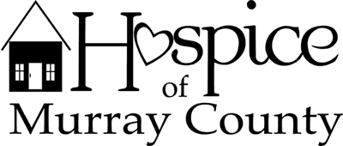

Administrator
Hospice of Murray County, a non-profit organization based in Slayton, is seeking an Administrator to lead our team in fulfilling the mission of providing hospice services to patients and their families with comfort, compassion, and dignity during the end stages of life. As the administrator, you are responsible for all aspects of hospice operations including: management and oversight of clinical processes, regulatory compliance, financial outcomes, operational procedures and the selection and development of staff.
Your leadership encourages a respectful and dignified environment for our interdisciplinary team, patients and their loved ones. If you have the proven ability to lead teams and are compassionate about quality care, then this may be just the calling for you.
Candidates should possess a minimum of 3-5 years in an administrative or supervisory capacity in a home health agency, hospice or other health related program, have excellent communication skills and a demonstrated leadership ability. Candidates should also possess a Bachelor’s Degree in business, health care, nursing or related field. Nursing diploma acceptable.
Interested candidates should submit a cover letter and resume to the Hospice Board of Directors at graphenteen@outlook.com. Questions can be directed to (507) 227-5402.

